- The first item in eah pair is voiceless, and the second item in each pair is voiced.

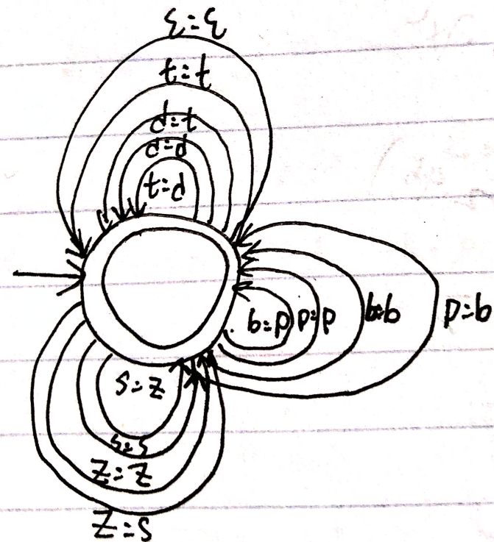
Ɛ=all phonemes.

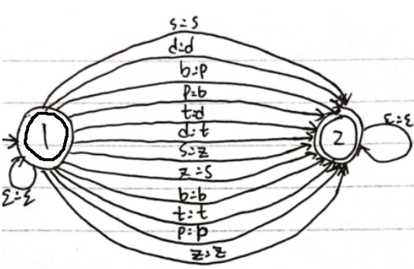
Ɛ=all phonemes.

4.
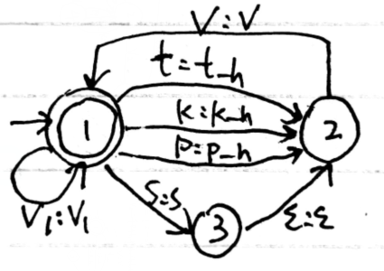
V1={ɛ-s}. V={ey1,eh1,ih1,uh1,ay1,ow1,oy1,iy1,aw1,uw1,aa1,ae1,ao1,ah1}.
Ɛ=all phonemes.

